

Center of Information Technology and Scientific Computing

Department of Software Engineering

Database Administration (DBA)

*Assignment two*

*Submitted by Henok Addis*

*Id: ATR/6271/09*

Submitted to Mr. Natnael A

Submitted Date: 07/11/2019

JDBC Drivers

**Java Database Connectivity (JDBC)** is an application programming interface (API) for the programming language Java, which defines how a client may access any kind of tabular data, especially relational database. It is part of Java Standard Edition platform, from Oracle Corporation. It acts as a middle layer interface between java applications and database.

The JDBC classes are contained in the Java Package **java.sql** and **javax.sql**.  
JDBC helps you to write Java applications that manage these three programming activities:

1. Connect to a data source, like a database.
2. Send queries and update statements to the database
3. Retrieve and process the results received from the database in answer to your query

JDBC drivers are client-side adapters (installed on the client machine, not on the server) that convert requests from Java programs to a protocol that the DBMS can understand. There are 4 types of JDBC drivers:

1. Type-1 driver or JDBC-ODBC bridge driver
2. Type-2 driver or Native-API driver
3. Type-3 driver or Network Protocol driver
4. Type-4 driver or Thin driver

**Type-1 driver/** **JDBC-ODBC bridge driver**

Type-1 driver or JDBC-ODBC bridge driver uses ODBC driver to connect to the database. The JDBC-ODBC bridge driver converts JDBC method calls into the ODBC function calls. Type-1 driver is also called Universal driver because it can be used to connect to any of the databases.

* As a common driver is used in order to interact with different databases, the data transferred through this driver is not so secured.
* The ODBC bridge driver is needed to be installed in individual client machines.
* Type-1 driver isn’t written in java, that’s why it isn’t a portable driver.

### **Advantages:**

* easy to use.
* can be easily connected to any database.

### **Disadvantages:**

* Performance degraded because JDBC method call is converted into the ODBC function calls.
* The ODBC driver needs to be installed on the client machine.

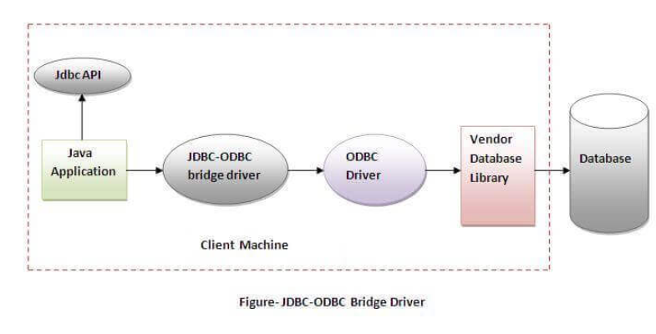

**Type-2 driver/** **Native-API driver**

The Native API driver uses the client -side libraries of the database. This driver converts JDBC method calls into native calls of the database API. In order to interact with different database, this driver needs their local API, that’s why data transfer is much more secure as compared to type-1 driver.

* Driver needs to be installed separately in individual client machines
* The Vendor client library needs to be installed on client machine.
* Type-2 driver isn’t written in java, that’s why it isn’t a portable driver

### **Advantage:**

* performance upgraded than JDBC-ODBC bridge driver.

### **Disadvantage:**

* The Native driver needs to be installed on each client machine.
* The Vendor client library needs to be installed on client machine.

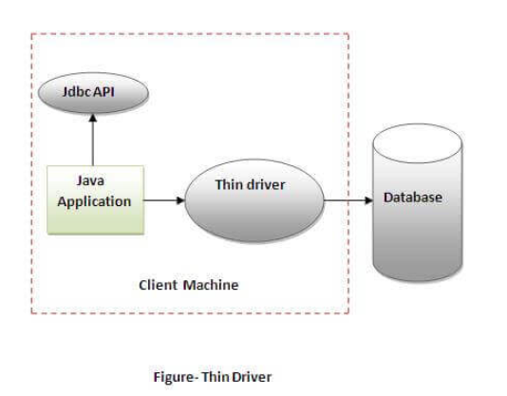

**Type-3 driver/** **Network Protocol driver**

The Network Protocol driver uses middleware (application server) that converts JDBC calls directly or indirectly into the vendor-specific database protocol. Here all the database connectivity drivers are present in a single server, hence no need of individual client-side installation.

* Type-3 drivers are fully written in Java, hence they are portable drivers.
* No client side library is required because of application server that can perform many tasks like auditing, load balancing, logging etc.
* Network support is required on client machine.
* Maintenance of Network Protocol driver becomes costly because it requires database-specific coding to be done in the middle tier.

### **Advantage:**

* No client-side library is required because of application server that can perform many tasks like auditing, load balancing, logging etc.

### **Disadvantages:**

* Network support is required on client machine.
* Requires database-specific coding to be done in the middle tier.
* Maintenance of Network Protocol driver becomes costly because it requires database-specific coding to be done in the middle tier.

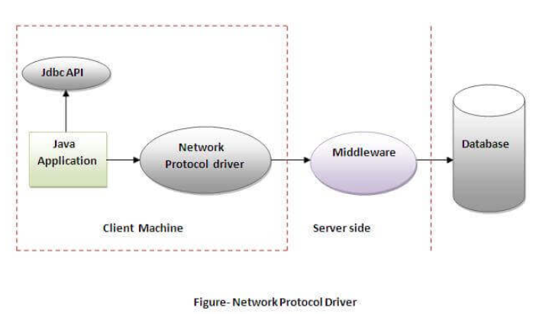

**Type-4 driver/** **Thin driver**

Type-4 driver is also called native protocol driver. This driver interact directly with database. It does not require any native database library, that is why it is also known as Thin Driver.

* Does not require any native library and Middleware server, so no client-side or server-side installation.
* It is fully written in Java language; hence they are portable drivers.

### **Advantage:**

* Better performance than all other drivers.
* No software is required at client side or server side.

### **Disadvantage:**

* Drivers depend on the Database.

